Lecture 5

Giving Instructions

At the end of our lecture you will be able to answer the following questions:
- What are the four keys to writing clear instructions?
- What two orders can you use to organize a "how to" paragraph?
- What are some time-order signals?
- What is an independent clause?
- What is a dependent clause?
- What is a complex sentence, and how do you punctuate one?
- What is a fragment?
- How do you correct a fragment? Capitalization and Punctuation
- What are the four capitalization rules in this lecture?
- What are four comma rules that you have learned?

Key words: Adverb Subordinators, a complex sentence, a clause, an independent clause, a dependent clause,a fragment, a "how to" paragraph

“How to Paragraph” is a paragraph that gives instructions. This kind of paragraph is sometimes called a "how to" paragraph because it explains how to do something or how to make something- how to change a flat tire or how to perform a science experiment, for example.
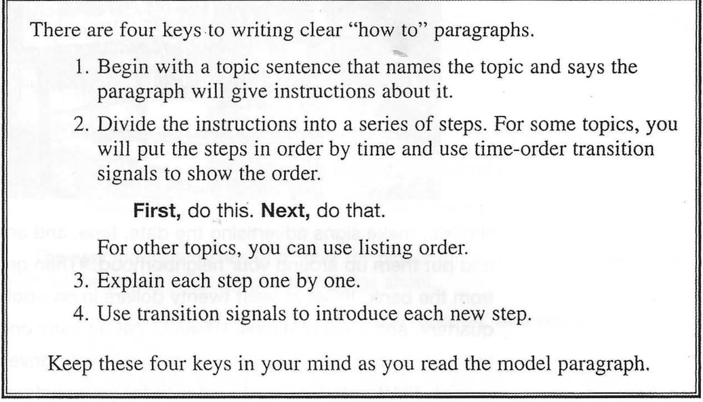
MODEL
HOW TO PARAGRAPH
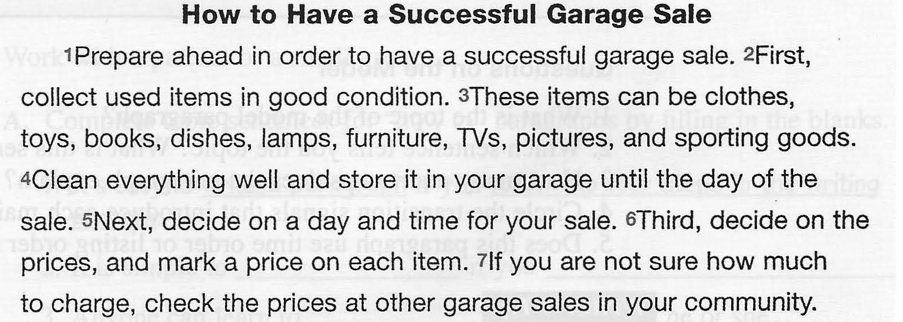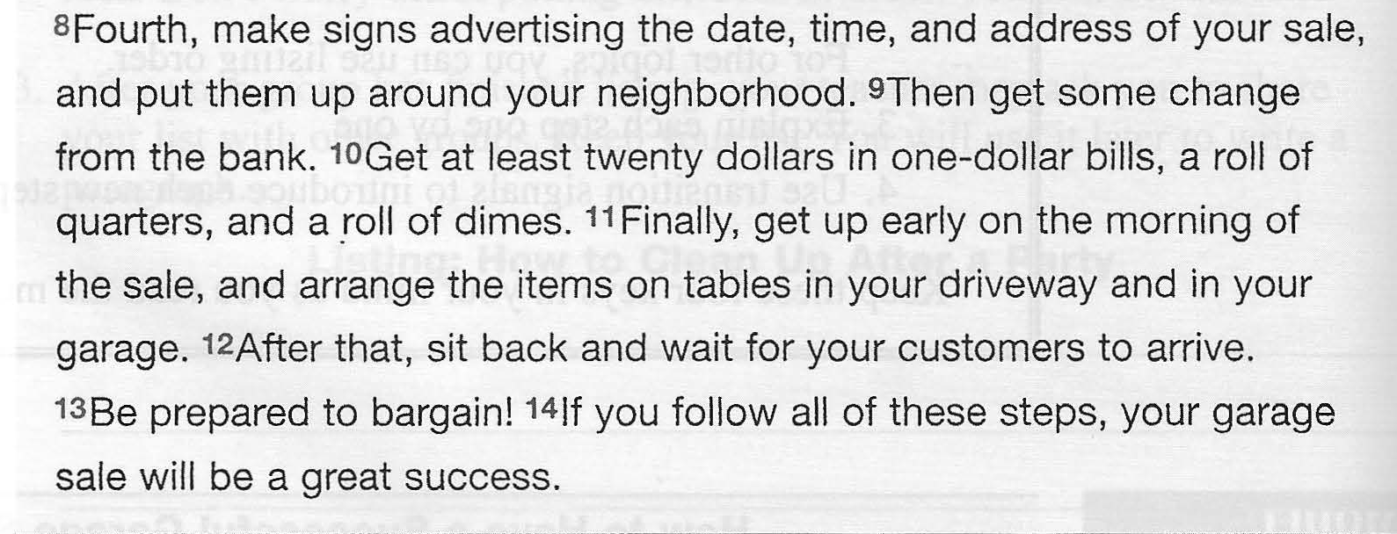
Questions on the Model
1. What is the topic of the model paragraph?
2. Which sentence tells you the topic? What is this sentence called?
3. How many main steps does the paragraph explain?
4. Circle the transition signals that introduce each main step.
5. Does this paragraph use time order or listing order to organize the steps?

Notice that many of the verbs in the model are commands: collect, clean, store, decide, mark, and so on. Use the command verb form to give instructions.

Topic and Concluding Sentences for "How To" Paragraphs
The topic part of a topic sentence for a "how to" paragraph names the topic
The controlling idea part tells your readers that they will learn how to do or make something. In the model paragraph, the topic sentence names the topic: a garage sale. It also tells what your paragraph will tell your reader about garage sales: how to prepare in order to have a successful one. Here are other examples of topic sentences for "how to" paragraphs. Notice that they use expressions such as by taking these steps, if you follow my advice, and follow these instructions. These expressions tell your reader that this is a "how to" paragraph.
Examples
Anyone can change a flat tire by taking these steps.
It's easy to soothe a crying baby if you follow my advice.
Follow these instructions to make delicious pizza.
The concluding sentence of a "how to" paragraph mentions the topic again to remind the reader what the paragraph was about.
Examples
In no time at all, your flat tire will be repaired, and you will be on your way again.
If you follow these four steps, your baby will fall asleep within five minutes.
You now have a delicious pizza to enjoy.
Time-Order Signals
In a "how to" paragraph, you can use either listing-order signals or time-orde signals. You have already learned about listing-order signals .
Notice that many listing-order and time-order signals are the same.
• If the steps in your instructions must be in a specific order (such as in the model paragraph about how to have a successful garage sale), use time-order signals.
• If the order doesn't matter, use listing-order signals.
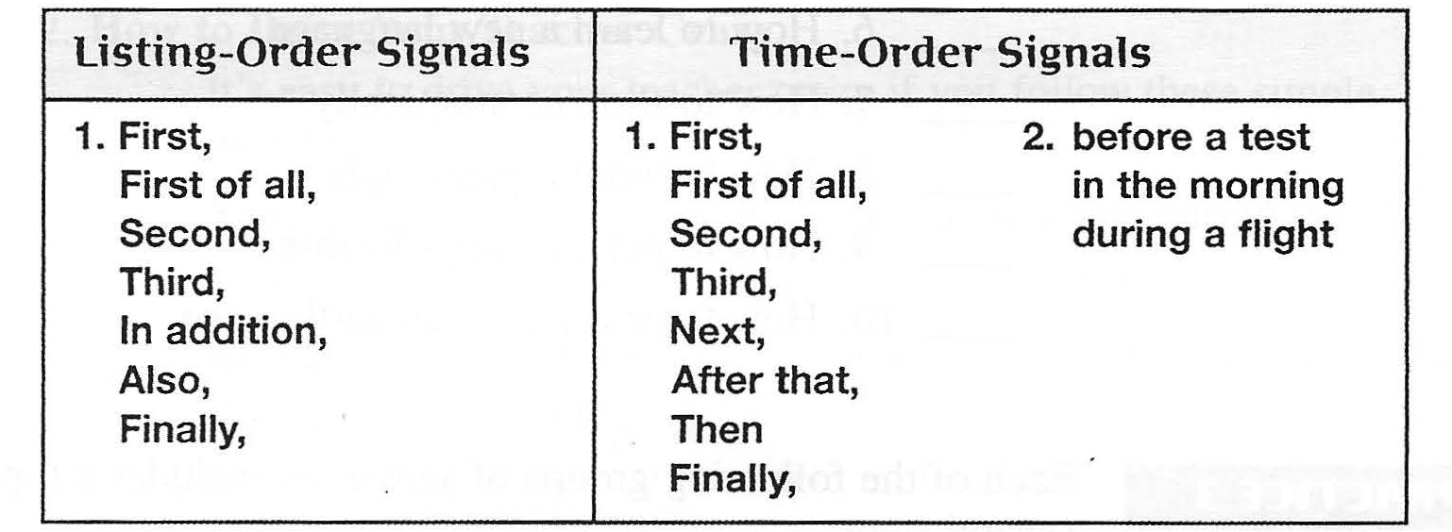

- These transition signals usually appear at the beginning of a sentence, followed by a comma. Then is an exception. Do not put a comma after then.
Examples
First, make the pizza dough.
Then add 2 cups of flour.

- You can use any time expression as a time-order signal. You can put time expressions such as these almost anywhere in a sentence.
Examples
Before a big test, get a good night's sleep.
In the morning, be sure to·eat breakfast.
Drink a lot of water during a flight.
Do not put a transition signal at the beginning of every sentence in a "how to" paragraph. A paragraph with too many transition signals is just as confusing to the reader as a paragraph with none! Use a transition signal with important steps, not with every step.

Here is the student's completed outline.
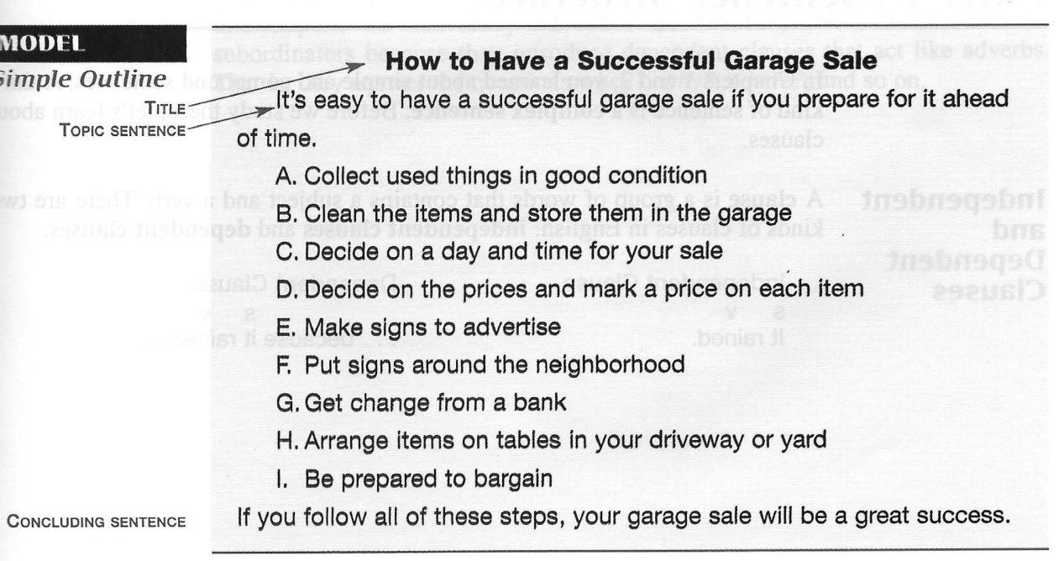

Sentense Structure. Complex Sentence
Earlier,you learned about simple and compound sentences.
A third kind of sentence is a complex sentence. Before we study these, let's learn about clauses.

Independent and Dependent Clauses

A clause is a group of words that contains a subject and a verb. There are two kinds of clauses in English: independent clauses and dependent clauses.
1. An independent clause has one SV pair and expresses a complete thought. Independent clause is just another name for a simple sentence.

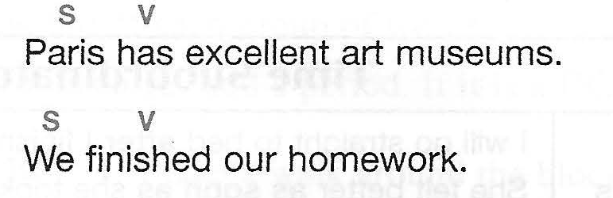

- A dependent clause is an independent clause with a subordinating word, such as because, after, and when, added to the beginning of it.

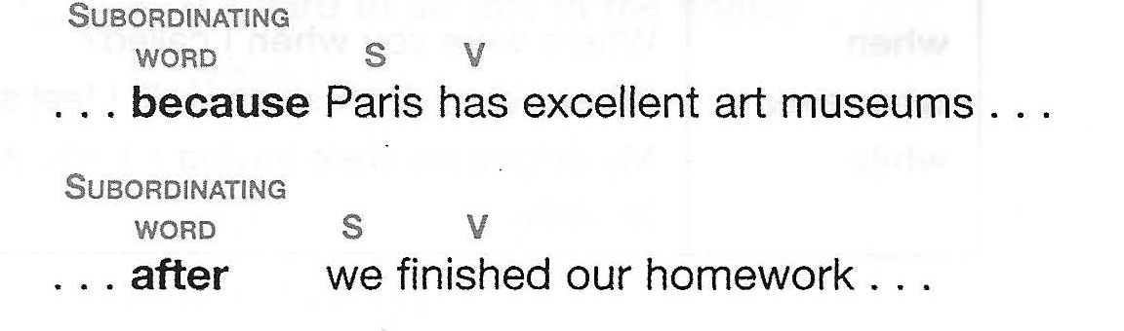

Adverb Subordinators
There are many subordinating words that can make a dependent clause. In this chapter, we will study adverb subordinators. We call them adverb subordinators because they introduce dependent clauses that act like adverbs. That is, they answer the questions when?, why?, where?, and so on.
Certain adverb subordinators introduce time clauses. Here are some common time subordinators.

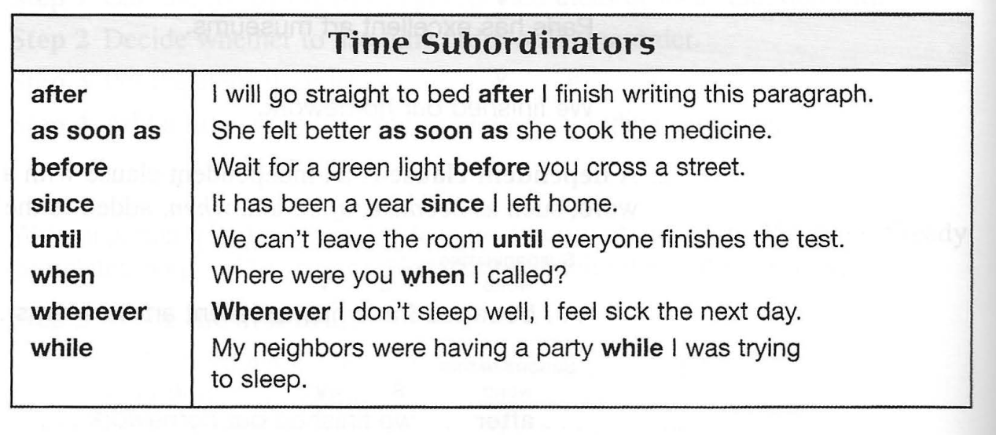

In addition to time-order transition signals, such as first, next, after that, and so on, you can use time clauses to show time order.
Examples
Before you start writing, look over the test.
After you have answered the easy questions, go back and work on the hard ones.

Complex Sentences
Now that you know about dependent and independent clauses, let's learn about complex sentences.

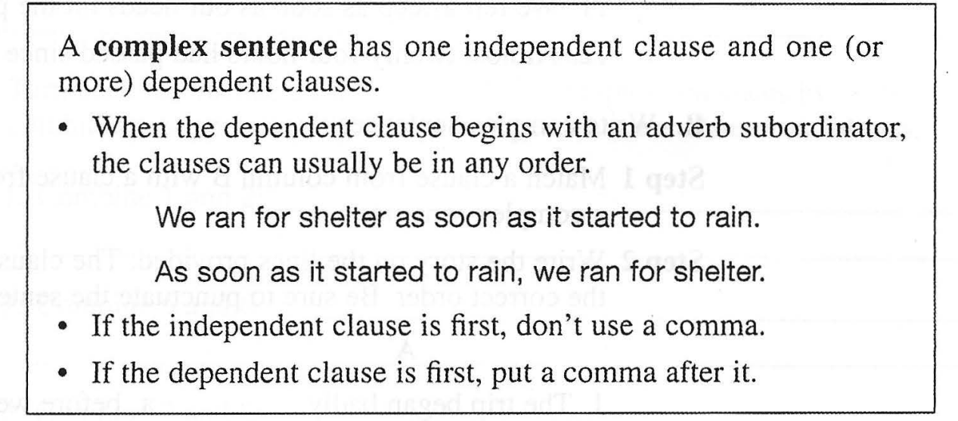

Sentence Errors: Fragments

A kind of sentence error is called a fragment. The word “fragment” means a part of something. A sentence fragment is only part of a sentence or half of a sentence. It is not a complete sentence. These are fragments:

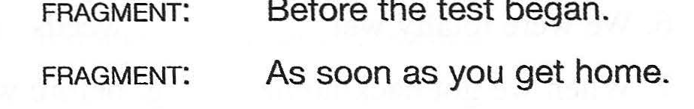

Why are they fragments? They are fragments because they are dependent clauses. A dependent clause cannot be a sentence by itself. To fix this kind of fragment, add an independent clause to it.

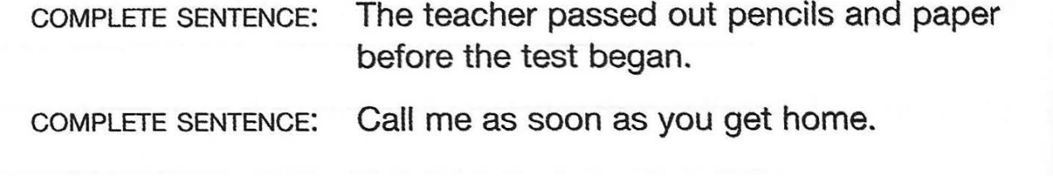

Let's summarize what you have learned about the three types of sentences. Good writers add interest and variety to their writing by using all three types.

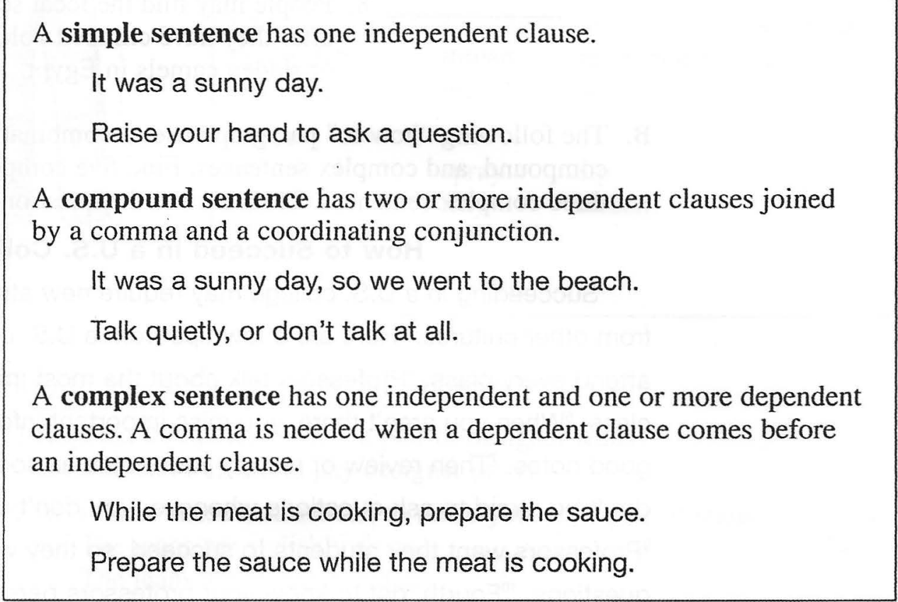

Capitalization: You learned six rules for capitalizing words in English. There are four additional rules.

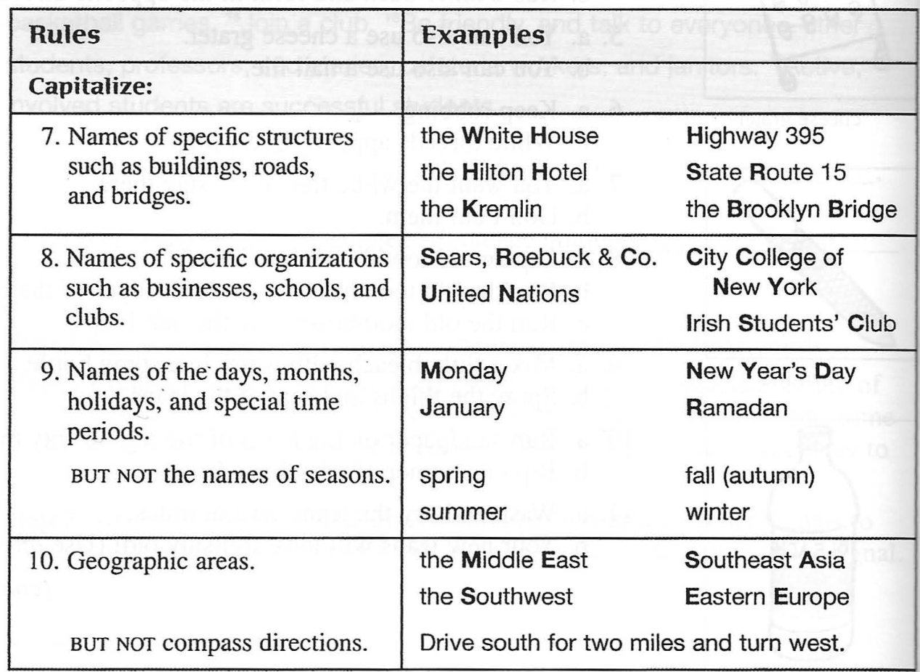

Commas: There are many rules for using commas. You have already learned three of them. Here is a fourth comma rule.

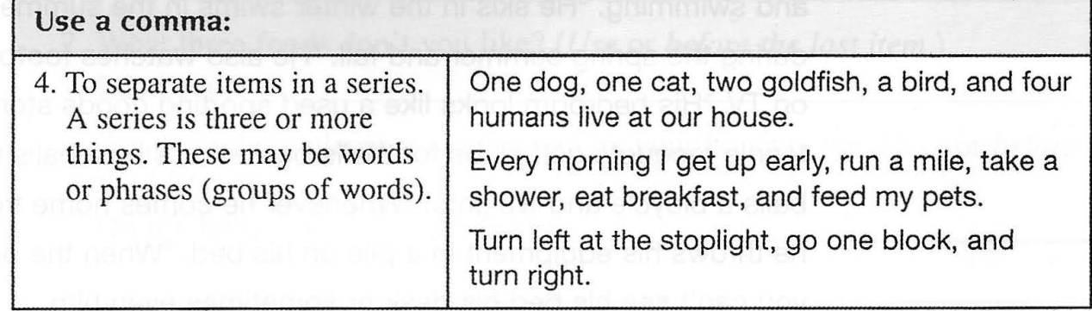

Notice that there is always one less comma than items. If there are four items, there are three commas; if there are five items, there are four commas; and so on.
- If there are three items in a series, some writers omit the last comma. However, it is a good idea to use all the commas because commas make your meaning clearer.
Examples
I have visited many countries in Europe, Asia, and America.
Shopping, relaxing, and visiting friends are my favorite weekend activities.
2. With only two items, don't use any commas.
Examples
I have visited many countries in Europe and Asia.
Sleeping and hanging out with friends are my teenage son's favorite weekend activities.

SOURCES
Ann Hogue, First Steps in Academic Writing/ 2nd edition, Level 2, the Longman Academic Writing Series. Pearson Longman,2006

